Oct 6th , 2025

Vocal Arts Booster

Club Meeting Minutes

Call to order: 6:03pm

Approval/Changes to the agenda: motion to approve -DeAnn, 2nd - Melinda

Approval of last month’s minutes: Susan/ Melinda

Treasurer’s Report: Susan

Balance: $12,153.31

Dance

Ticket sales: $8,235

Concession: $387

Photo Booth: $304

Expense: $1,312.64

Total from dance: $8,926

Old Business

Homecoming was a success

Float

Thank you to the parents that helped. The kids loved it and our attendance was noticed/appreciated.

Dance

Thank you to ALL who helped. We had the best turnout yet of volunteers.

Despite the weather, the dance was a success

Brought in:$7,613.36

All District tryouts were last weekend. Goodluck bags were delivered to the site to encourage all the students auditioning

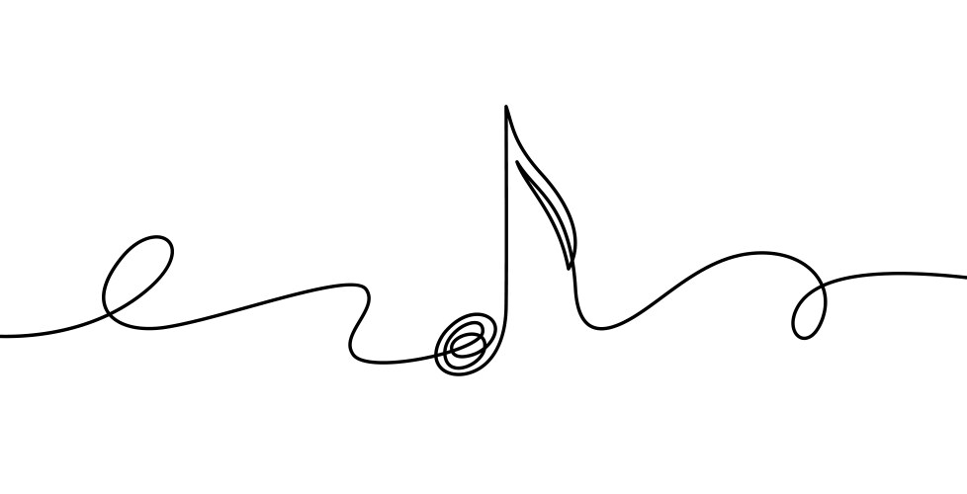
new business

This year’s events

Mummy & Son Dance – Ticket are on sale on the website now

Fri Oct. 24th.

Time:6-8pm ticket price: $15 presale/ $20 door

Location: CUE gym

Volunteers Needed

Setup time: 4:00pm

Chaperones: 5:45-8:00pm

Clean up: 8-9pm

Activities at the dance

Costume contest

Prizes: Susan purchased some Halloween decorations, grab bag bucket with candy or toys suggested.

Musical chairs?

4 Corner dice game like the roller rink used to do. Ashley Ward has a dice. Keeps chairs off floor and does same concept.

Freeze Dances

Heads & Tails Coin Flip: touch your head or butt to predict the flip

Couple dances/ lead dances/ themed dances?

Susan has asked the DJ about ideas. He is thinking

Advertising went out Oct. 3rd to Herald and CUE as well as online

We have not received permission from ECC yet

Ashley Ward will print and pass out flyers to ECC due to principal is not there right now.

Susan will lead decorating the gym, Melinda the lobby, Lisa the Photo Booth

Auditions

Next Meeting

Nov 3rd , 2025

All State round 1 –Sat. Nov 1st , 2025

Chaperones needed to ride bus

Water, hard candies

DeAnn Wood has volunteered to make the bags

Boar’s head

Dec. 12th 13th, & 14th

VOLUNTEERS NEEDED – please let us know if you want to sign up

Volunteers for this event will receive a free ticket to event

DeAnn, Ashley, Lisa, Ben, Susan, Melinda

Details will be discussed more at Nov meeting

Open floor

Justin: Suggestion of programs made for Boar’s Head. Lacy would like to do.

Mr. B: File Cabinet issue – Scott Odar has come up with a plan and volunteered to construct 4 cabinets for the choir. Cost would only be $2,053 for a big saving to choir. Big thanks

Susan: Do we have other $ needs for the year?

We have min 1 All State jacket at this point

Jeremy made jazz All State

Boar’s Head upfront

Mr B has to pay for ham since we are buying through school.

We pay everything else

We Give profit made off this event all to choir

CutTime – school has to buy + boosters will reimburse

Musical adutitions are Dec. 15th & 16th

No tree lighting this year
DATES TO REMEMBER:
Oct 6th Booster Meeting
Oct 9th MS choir National Anthem
Oct 13th Children’s ALL State
Oct 14th Meet the Choir
Oct 24th Mummy & Son Dance
Nov 1st All State round #1
Nov 3-4 All District Clinic
Nov 3rd Booster Meeting
Nov 7th Senior Night @ Football Game
Nov 15th HS All State round #2
Nov 18th MS All State round #2
Dec 1st Christmas Tree Lighting
Dec 5th OU Young Men Sing
Dec 8th Booster Meeting
Dec 12-14 Boar’s Head Feast

No OU Men Sing this year

adjounment: 6:40pm

Attendance:

Ben Vassmer

Lisa Vassmer

Susan Scott

Melinda Clary

Ashley Ward

DeeAnn Wood

Holly Wood

Krista Nissen

Justin McGrew

Micheal Broyles

