Sept 3rd , 2025

Vocal Arts Booster

Club Meeting agenda

Call to order:

Approval/Changes to the agenda:

Approval of last month’s minutes:

Treasurer’s Report: Susan

Old Business

New directors: HS – Mr. Broyles, MS – Mrs. Shilling

$200 given for director’s event

new business
Pres: Ben Vassmer | Vice Pres: Melinda Clary
Treasure: Susan Scott | Secretary: Lisa Vassmer

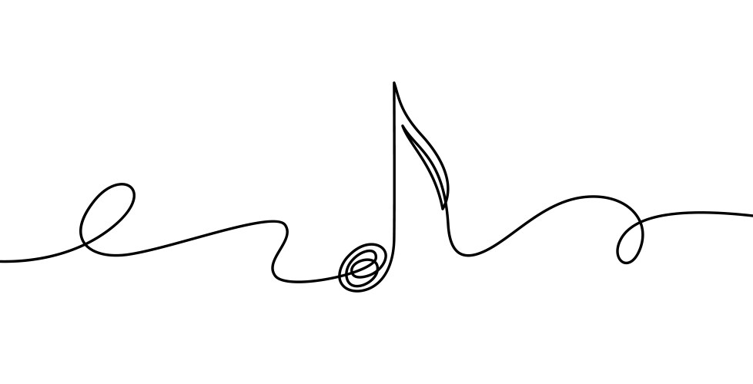
Introductions of this year’s officers

New Name: Collinsville Vocal Arts Booster

We now include all vocal arts: choir & musical theater

We have a new logo!

Due to name change, we have new bylaws reflecting that change

Homecoming

Parade -Sept 19th 2:30pm

Trailer/truck

Volunteers

Setup time: ___________

Dance – Sept 20th @7:00pm

Theme: A Night in the Garden

Advertising started: Aug 27th

Tickets – on sale now

$15 in advance, $20 after Sept. 16th.

Purchase from Penny @ school or online w/ Venmo or Cashapp

Volunteers – sign-up sheets & sign up genius

Setup Fri – Time:_________________

Setup Sat ?

Chaperones/ check in/ concession: 6:45pm-10:00pm

Clean up Sun- Time: __________

Concessions

Drinks $_____ for ________________________

Food $_____ for ___________________________

Photobooth

$2/person

New booth idea for this year!

Donations needed

Decorations

Lights

Topiaries

Benches

Anything else? _________________

Food Drive

Suggestion of doing a food drive for MOMs as a way to get the booster involved in the community

When: _____________

Needs request for sent to board

Scentsy Fundraiser

Tracy James has offered to run a Scentsy fundraiser for us. We put in a request with the board to start it later this month

It will run on the Facebook page for about 4 weeks.

25% of sales will go to the boosters!

Mummy & Me Dance

Fri Oct. 24th.

Time:___________ ticket price ____________

Location: CUE gym

Volunteers needed

Details will be worked out next meeting

Advertising needs to go out OCT 1-3Community Service

Donations

Suggestion to have families donate water and snacks for goodie bags.

We have several auditions coming up where treat bags make the kids feel good. Do we want to see about parents donating water or snacks? We will then have committees that can stuff and coordinate the distribution for the events

Auditions

All District – Sat. Oct 4th, 2025

Chaperones needed

2 to ride bus

2-3 meet at location

Goodie bags to encourage kids trying out.

Water, hard candies, granola bars, nice message (directors supply)

Who wants to lead this: _____________________________

All State round 1 –Sat. Nov 1st , 2025

Chaperones needed to ride bus (see directors)

Goodies

Water, hard candies, snack

Who wants to lead this _______________________

HS All State round 2 – Sat Nov. 15th

Water, hard candies, snack

Who wants to lead this _______________________

MS All State round 2 – Tues. Nov. 18th

Water, Candies, snack

Who wants to lead this one ________________________

Boar’s head

Dec. 12th 13th, & 14th

VOLUNTEERS NEEDED

Volunteers for this event will receive a free ticket to event

Set up: Fri. 12/12 afternoon

All show events – food prep & plating (kids do serving and dining room clean up)

12th = 1 show

13th = 2 shows (1 afternoon & 1 evening)

Clean up: Dec. 14

Senior’s

We have 4 seniors this year

Next Meeting

Oct. 6th 2025

What Sr activities would we like to aim for this year?

Melinda??

Open floor
DATES TO REMEMBER:
Sept 2nd Meet the Parents
Sept 3rd Booster Meeting
Sept 3rd Choir fees due
Sept 19th Homecoming Parade
Sept 20 Homecoming Dance
Oct 2nd Meet the Choir
Oct 4th All District Auditions
Oct 6th Booster Meeting
Oct 24th Mummy & Me Dance
Nov 1st All State round #1
Nov 3-4 All District Clinic
Nov 3rd Booster Meeting
Nov 7th Senior Night @ Football Game
Nov 15th HS All State round #2
Nov 18th MS All State round #2
Dec 1st Christmas Tree Lighting
Dec 5th OU Young Men Sing
Dec 8th Booster Meeting
Dec 12-14 Boar’s Head Feast

adjounment
Thank you to all the
Volunteers
Who already signed up!

